**School of Computer Science and Engineering**

**DEV TRACK Club Report**

**Date: 25th September 2023**

**Venue: Kuvempu Auditorium, CV Raman Block**

**Programme Organised:**

**Objectives of the Event**

* To inspire and motivate students and professionals by showcasing the success story of Mr. Ishan Sharma and the challenges he overcame on his career path.
* To provide attendees with practical advice and insights on building a successful career, including the acquisition of essential skills and traits.
* To foster networking opportunities by highlighting the importance of building strong relationships in the industry, as evidenced by speaker’s interactions with various entrepreneurs and business leaders. The event aimed to increase awareness of the significance of industry connections in career progression.

**Club Description**

Dev/Track is our university's premiere student circle to ideate, innovate and implement various solutions to tackle real-world problems in different tracks including AI/ML, web3, Mobile App Development, and Web development. Our mission revolves around connecting enthusiastic minds seeking opportunities to collaborate and contribute. Dev/Track provides a forum for students to showcase their skills while building their repertoire and Resume. We aim to sculpt an environment to help students realize their potential and encourage them to contribute to a broader tech eco-space.

**Description of the Event in chronological order**

The event started by welcoming the guests of the event. The guest included ……………

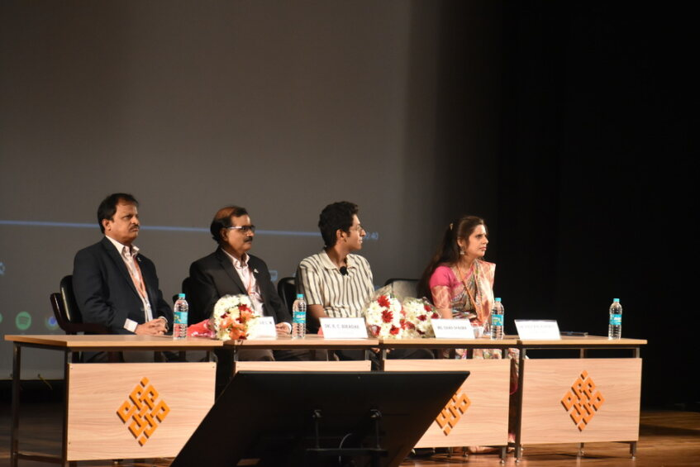

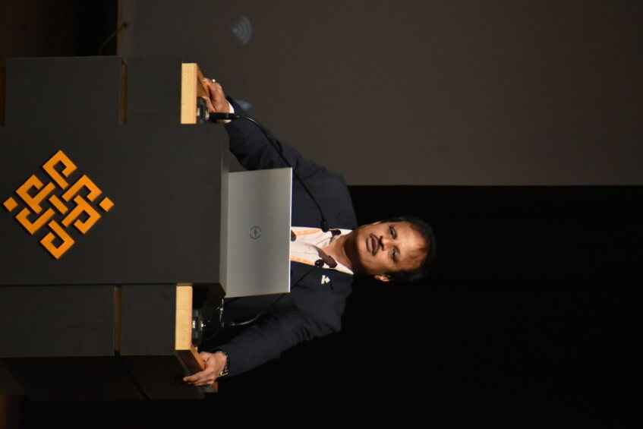Mr Ashwin Kumar Sir and Mr _____________, gave welcome speech about the event.

Mr. Ishan Sharma began the session by sharing some of his early life experiences and challenges he faced while pursuing his career goals.

During his presentation, He shared pictures of himself with various entrepreneurs and business leaders. These images served as a visual reminder of the significance of networking and building strong relationships in the industry. He encouraged attendees to actively network and nurture professional connections through social media like LinkedIn.

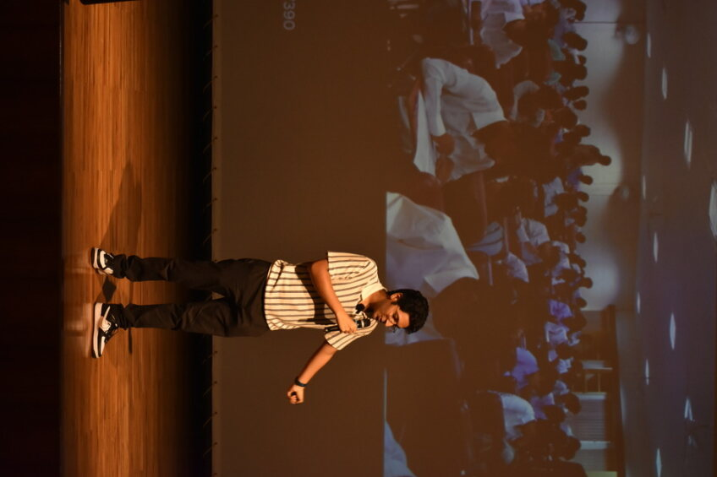

Attendees received important advice on the acquisition of sales and marketing skills. He emphasized that these skills are vital for anyone looking to excel in their career. He discussed strategies for effective sales and marketing and how they can lead to professional growth. He shared valuable insights into the common traits that successful people possess. He highlighted the five key traits: knowledge, skill, network, reputation, and resources. He emphasized that these traits play a crucial role in achieving and sustaining success in any field.

In addition to career-related topics, He also highlighted the importance of taking care of one's health. He stressed that a healthy body and mind are essential for long-term career success. Attendees were given practical tips on maintaining a work-life balance and prioritizing their well-being. He concluded the talk by discussing the role of artificial intelligence (AI) in increasing productivity. He shared insights into how AI technologies can be harnessed to streamline tasks, save time, and enhance efficiency in various professions. Attendees were encouraged to explore AI tools to boost their productivity.

After the speaker's presentation, the audience enthusiastically participated in question-answer sessions. Attendees had the opportunity to ask questions and seek personalized advice on their career paths, which added an interactive and informative dimension to the event. This engagement demonstrated a genuine interest in the material presented and a desire to gain a deeper understanding.

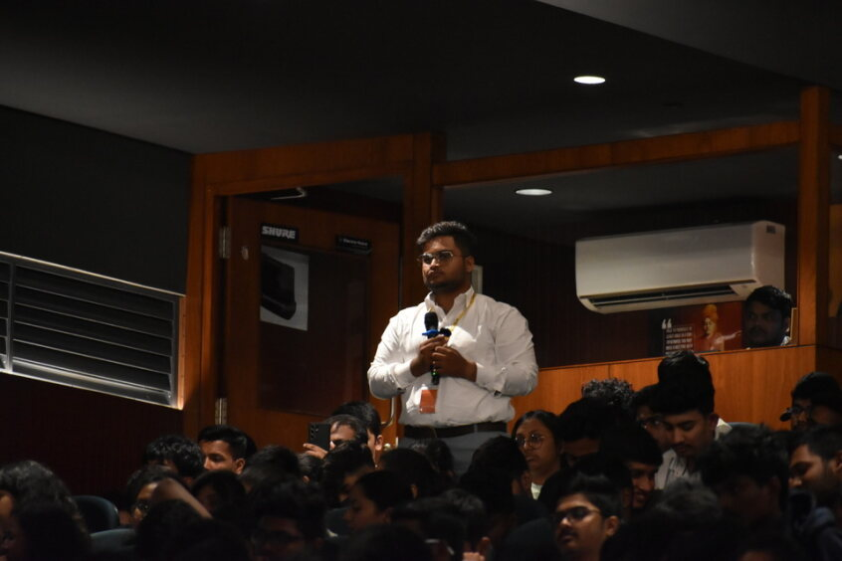

The event attracted a diverse audience, including technology professionals, entrepreneurs, students, and tech enthusiasts. Attendees actively participated in the event demonstrating a keen interest in the topics discussed.

**Conclusion**

The "Elevating Your Carrer with Ishan Sharma " talk event was a resounding success, providing attendees with valuable insights in developing a career in this ever-changing world.

The event successfully achieved its goal of inspiring and guiding individuals to pursue their career aspirations with determination and vision. It served as a reminder that success is achievable through hard work, dedication, and a commitment to lifelong learning.

We extend our sincere gratitude to Mr. Ishan Sharma for taking the time to share his wisdom and experiences with us, and we look forward to hosting more such events in the future to foster innovation and knowledge sharing within the community.

**Acknowledgement**

We would like to express our gratitude to Mr. Ishan Sharma for his engaging and insightful presentation. We also would like to thank our director and faculty and providing the opportunity and support required for organizing the event. At last, we would like to thank all the volunteer who help us organize this grand event.